

SafeRoute AI: Intelligent Road Hazard Detection and Accident Prevention System Industry Context

ARCHITECTURE DESIGN ASSIGNMENT
Submitted in the Partial fulfilment for the course of
CSA1012- SOFTWARE ENGINEERING
To the award of the degree of
BACHELOR OF ENGINEERING
IN
ARTIFICIAL INTELLIGENCE AND MACHINE LEARNING
Submitted by
P.TEJASWINI(192525171)

Under the Supervision of
Dr. K. ANITA DAVAMANI

SIMATS ENGINEERING
Saveetha Institute of Medical and Technical Sciences
Chennai-602105

1. Introduction
1.1 Purpose of This Document
This document defines the software architecture for SafeRoute AI, an intelligent road hazard detection and accident prevention system. It describes the system’s objectives, functional and non-functional requirements, selected architectural style, component design, quality attribute scenarios, and the rationale behind key architectural decisions. The report is intended for stakeholders including development teams, transportation authorities, and academic evaluators to understand how the system is structured to meet safety, performance, and scalability goals.
1.2 Scope
SafeRoute AI addresses the critical problem of road traffic accidents caused by poor road conditions, unexpected obstacles, adverse weather, and delayed driver response. The system integrates AI-based computer vision, GPS, and IoT sensors to detect hazards (potholes, debris, waterlogging, damaged signs) in real time, map them geospatially, and provide instant alerts and alternative route recommendations to drivers. It also supports predictive analytics for accident-prone zones and generates maintenance reports for transportation authorities. The scope covers edge inference on vehicles, cloud-based microservices for ingestion and analytics, real-time alerting, and authority dashboards.

1.3 Background and Motivation
Road traffic accidents remain a leading cause of injuries and fatalities worldwide, creating significant social and economic challenges. Existing navigation applications focus primarily on route optimization rather than real-time hazard detection, and manual reporting systems are too slow to provide immediate warnings. Advances in AI, computer vision, GPS, and IoT enable continuous monitoring of road environments and proactive hazard detection. SafeRoute AI leverages these technologies to improve driver awareness, reduce accidents, and support smart city initiatives through a scalable, intelligent road safety platform.
1.4 Definitions, Acronyms, and Abbreviations
- Edge AI: On-device machine learning inference performed on vehicle-mounted hardware.
- IoT (Internet of Things): Network of physical devices (sensors, cameras) embedded with software for data exchange.
- V2X (Vehicle-to-Everything): Communication technology enabling vehicles to share data with other vehicles, infrastructure, and networks.
- PostGIS: Geospatial database extension for PostgreSQL, used for storing and querying hazard locations.
- ATAM (Architecture Tradeoff Analysis Method): Structured method for evaluating software architectures against quality attributes.
- 4+1 View Model: Architecture documentation framework comprising Logical, Process, Physical, Development views, plus Scenarios.

2.System Requirements Analysis
2.1 System Objectives
The SafeRoute AI system is designed to achieve the following high-level objectives:
- Real-time Hazard Detection: Continuously monitor road conditions using AI-powered computer vision and IoT sensors to identify hazards such as potholes, debris, waterlogging, and damaged signs.link.springer+1
- Geospatial Mapping: Associate each detected hazard with precise GPS coordinates and timestamps for accurate location-based services.ewadirect
- Instant Driver Alerts: Push real-time warnings to nearby drivers and provide alternative route recommendations to avoid hazardous zones.ncaidt.ganitara+1
- Predictive Analytics: Analyze historical and real-time traffic data to predict accident-prone zones and enable proactive safety measures.ewadirect
- Authority Support: Maintain a centralized hazard database and generate maintenance reports for transportation authorities and emergency responders.
- Scalability and Reliability: Support thousands of vehicles and high-frequency sensor streams with high availability and fault tolerance.ncaidt.ganitara

2.2 Functional Requirements
The following functional requirements define what the system must do to meet its objectives:
ID | Requirement | Description
FR-01 | Data Acquisition | Ingest video streams from vehicle-mounted cameras and telemetry data from IoT sensors (IMU, GPS, environmental sensors). ijsret
FR-02 | Hazard Detection | Run on-device/edge computer vision models to classify hazards (potholes, debris, waterlogging, damaged signs) and estimate severity. link.springer
FR-03 | Geotagging & Mapping | Associate each hazard detection with GPS coordinates, timestamp, and confidence score; store in a central geospatial database. ewadirect
FR-04 | Real-time Alerts | Push instant warnings to drivers within a defined proximity of detected hazards; include severity and alternative route suggestions. ncaidt.ganitara+1
FR-05 | Routing Integration | Integrate with maps/routing APIs to compute and suggest safer alternative routes in real time. ncaidt.ganitara+1
FR-06 | Predictive Analytics | Compute risk scores for road segments using historical accidents, traffic density, weather, and road geometry; update dynamically. ewadirect
FR-07 | Authority Dashboard | Provide a web-based dashboard for transportation authorities to visualize hazard hotspots, generate maintenance reports, and prioritize interventions.
FR-08 | Notification Service | Dispatch push/SMS/email alerts based on user subscriptions and proximity to hazards.
FR-09 | External Integrations | Connect to weather APIs, emergency notification channels, and third-party mapping services.
FR-10 | Data Retention & Archival | Store hazard records, analytics data, and media (video clips/images) for audit, compliance, and model retraining. ncaidt.ganitara

2.3 Non-Functional Requirements (Quality Attributes)
The following non-functional requirements define how the system must behave to ensure quality, performance, and security:
ID | Quality Attribute | Requirement
NFR-01 | Scalability | Support ingestion and processing of hazard events from thousands of vehicles simultaneously; horizontally scale services to handle 10x traffic spikes during peak hours. ncaidt.ganitara
NFR-02 | Performance | Achieve end-to-end latency of ≤2 seconds from hazard detection to driver alert; p95 API response time ≤500ms for browsing and routing queries. ijsret+1
NFR-03 | Availability | Maintain 99.9% uptime for critical services (alerting, routing, ingestion); implement multi-AZ deployments and failover mechanisms. ncaidt.ganitara
NFR-04 | Reliability | Ensure zero data loss during connectivity gaps using edge store-and-forward buffering; implement idempotent event handlers and deduplication. ijsret
NFR-05 | Security | Enforce mutual TLS and device certificates for vehicle authentication; encrypt data in transit (TLS) and at rest; implement RBAC for authority dashboards.
NFR-06 | Maintainability | Modular microservices with clear API contracts; automated CI/CD pipelines; comprehensive logging, monitoring, and alerting. ncaidt.ganitara
NFR-07 | Usability | Intuitive driver alerts with minimal false positives; accessible authority dashboards with drill-down analytics.
NFR-08 | Compliance | Adhere to local data privacy regulations (e.g., GDPR, India's DPDP Act) and transportation safety standards.

2.4 Quality Attribute Scenarios
To make quality requirements measurable, we define scenarios using the SEI template (Source, Stimulus, Environment, Artifact, Response, Response Measure).github+2
ID | Quality Attribute | Scenario
QA-01 | Performance | Source: Vehicle. Stimulus: High-confidence hazard detected. Environment: Normal operation. Artifact: Ingestion Service. Response: Event published to message broker. Measure: p95 latency ≤500ms.
QA-02 | Scalability | Source: Traffic spike. Stimulus: 10x increase in hazard events. Environment: Peak hours. Artifact: Message Broker. Response: Auto-scale consumers. Measure: Handle 10x traffic within 10 minutes.
QA-03 | Security | Source: Attacker. Stimulus: Unauthorized API access attempt. Environment: Normal operation. Artifact: API Gateway. Response: Request rejected and logged. Measure: Zero unauthorized accesses.
QA-04 | Reliability | Source: Network. Stimulus: Connectivity loss for 5 minutes. Environment: Rural area. Artifact: Edge AI Module. Response: Buffer events locally. Measure: Zero data loss.
QA-05 | Availability | Source: Cloud. Stimulus: Primary database failure. Environment: Normal operation. Artifact: Hazard DB. Response: Failover to replica. Measure: RTO ≤5 min, RPO ≤1 min.
QA-06 | Maintainability | Source: Developer. Stimulus: New hazard type added. Environment: Development. Artifact: Hazard Service. Response: Deploy new model version. Measure: Deployment time ≤1 hour.

3. Selected Software Architecture
Architecture Principles
- Loose Coupling: Services communicate via well-defined APIs and events; no direct database sharing.ncaidt.ganitara
- High Cohesion: Each service has a single, well-defined responsibility (e.g., Hazard Management handles only hazard CRUD).ncaidt.ganitara
- Fail-Fast with Graceful Degradation: Services fail quickly but provide fallback behavior (e.g., cached routes if analytics is unavailable).ijsret
- Security by Design: Mutual TLS, device certificates, RBAC, and encryption enforced at all layers.
- Observability First: Comprehensive logging, metrics, and tracing for every service

4. Components and Their Interactions
4.1 Component Overview
The SafeRoute AI system is decomposed into the following major components, each with a well-defined responsibility and interface.
Component | Responsibility | Deployment Location
Edge AI Module | Sensor fusion, on-device computer vision inference, hazard event generation, local buffering. ijsret | Vehicle-mounted hardware (embedded device or smartphone).
API Gateway / Ingestion Service | Authenticate devices, validate payloads, rate limiting, publish HazardDetected events to broker. ncaidt.ganitara+1 | Cloud (multi-AZ).
Hazard Management Service | Deduplicate hazards, assign severity scores, manage lifecycle (active/resolved), persist to geospatial DB. ewadirect | Cloud.
Alert & Routing Service | Identify affected drivers, compute alternative routes, trigger notifications. ncaidt.ganitara+1 | Cloud.
Predictive Analytics Service | Train/run risk-scoring models, update accident-prone zone predictions, publish RiskUpdated events. ewadirect | Cloud.
Authority Dashboard Service | Serve web-based dashboards, generate maintenance reports, visualize hotspots. jai.aspur | Cloud.
Notification Service | Dispatch push/SMS/email alerts based on subscriptions and proximity. jai.aspur | Cloud.
Message Broker / Event Bus | Pub/sub backbone for decoupled event processing (e.g., HazardDetected, AlertIssued, RiskUpdated). ijsret+1 | Cloud (clustered).
Data Stores | PostGIS (hazards, road segments), Redis (cache), S3/Object Storage (media), Analytics DB/Data Lake. ncaidt.ganitara+1 | Cloud.
External APIs | Maps/Routing (e.g., Google Maps, Mapbox), Weather (e.g., | Third-party.

4.2 Detailed Component Descriptions
Edge AI Module
- Purpose: Perform real-time hazard detection on vehicles using camera and sensor data.
- Responsibilities:
  - Capture video frames and IMU/GPS telemetry.
  - Run lightweight computer vision models (e.g., YOLO, MobileNet) to detect potholes, debris, waterlogging, damaged signs.ijsret
- Interfaces:
  - Outbound: HTTPS/MQTT to API Gateway (hazard events).
  - Inbound: Configuration updates (model versions, thresholds).
API Gateway / Ingestion Service
- Purpose: Single entry point for all vehicle-uploaded data; enforce security and validation.
- Responsibilities:
  - Authenticate devices using mutual TLS and JWT tokens.
  - Validate hazard event payloads (schema, range
- Interfaces:
  - Inbound: REST/MQTT from Edge AI Modules.
  - Outbound: Message Broker (HazardDetected events).
Hazard Management Service
- Purpose: Maintain a canonical, deduplicated record of all detected hazards.
- Responsibilities:
  - Consume HazardDetected events from the broker.
  - Deduplicate based on location, time, and hazard type.
  - Assign severity scores (low/medium/high) using rules or ML.
  - Persist hazards to PostGIS with metadata (type, severity, confidence, media links).ewadirect
  - Publish HazardConfirmed/HazardResolved events.
- Interfaces:
  - Inbound: Message Broker (HazardDetected).
  - Outbound: PostGIS (write), Message Broker (HazardConfirmed).

4.3 Data and Control Flow
Hazard Detection and Alert Workflow
- Edge AI Module detects a pothole and generates a HazardDetected event with GPS coordinates, timestamp, and confidence score.ijsret
- API Gateway authenticates the device, validates the payload, and publishes the event to the Message Broker.ncaidt.ganitara+1
- Hazard Management Service consumes the event, deduplicates, assigns severity, and persists to PostGIS. It then publishes a HazardConfirmed event.ewadirect
- Alert & Routing Service consumes HazardConfirmed, identifies nearby drivers, requests alternative routes from the Maps API, and sends an AlertRequest to the Notification Service.ncaidt.ganitara+1
- Notification Service dispatches push/SMS alerts to affected drivers with hazard details and route suggestions.jai.aspur
- Predictive Analytics Service consumes hazard streams to update risk scores for affected road segments and publishes RiskUpdated events.ewadirect

4.3.2 Authority Reporting Workflow
- Authority Dashboard Service queries PostGIS and Analytics DB for hazard hotspots and risk trends.
- Generates a maintenance report (PDF/CSV) and stores it in S3.
- User downloads the report via the web dashboard.jai.aspur

4.4 Interaction Diagrams
Sequence Diagram (Hazard Detection → Alert)
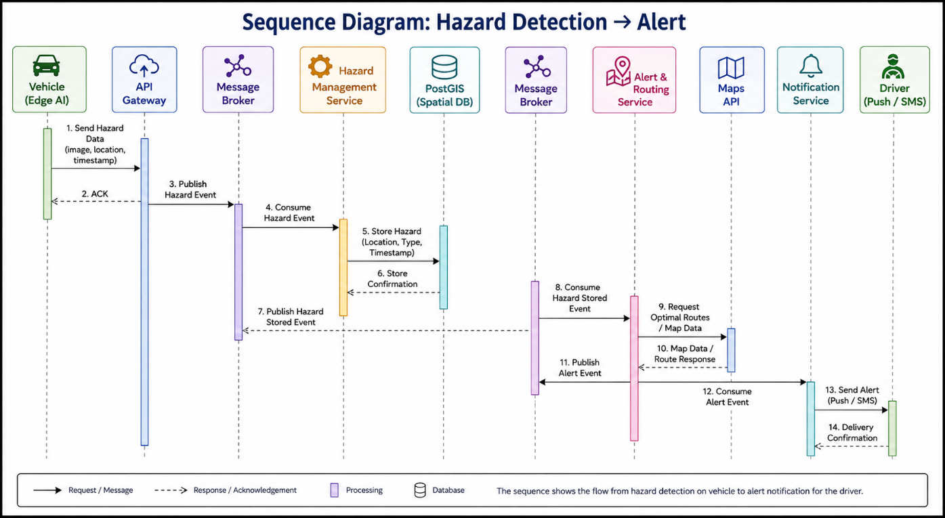

Integration Points and Contracts
- API Contracts: REST endpoints for ingestion (POST /hazards), dashboard queries (GET /hazards?bbox=...), and report generation (POST /reports).
- Event Schemas: JSON schemas for HazardDetected, HazardConfirmed, AlertIssued, RiskUpdated (versioned for backward compatibility).
- Authentication: Mutual TLS for vehicle-to-cloud; OAuth2/JWT for dashboard users.ncaidt.ganitara+1
- Fallback Behavior: Serve cached routes or last-known hazard data if analytics is temporarily down.

5. Quality Attribute Scenarios
5.1 Overview
Quality attribute scenarios make non-functional requirements measurable and testable. Each scenario follows the SEI template: Source, Stimulus, Environment, Artifact, Response, and Response Measure. This section defines 8–10 scenarios covering scalability, security, performance, reliability, maintainability, and availability for SafeRoute AI.quality.

5.2 Quality Attribute Scenario Template
Field | Description
Source | Entity generating the stimulus (e.g., vehicle, attacker, developer).
Stimulus | Event or condition that triggers the scenario (e.g., hazard detected, attack attempt).
Environment | System state when stimulus occurs (e.g., normal operation, peak load, failure).
Artifact | System component affected by the stimulus (e.g., Ingestion Service, API Gateway).
Response | Action taken by the system in response to the stimulus.
Response Measure | Quantifiable metric to evaluate the response (e.g., latency, uptime, deployment time).

7.Architecture Diagram
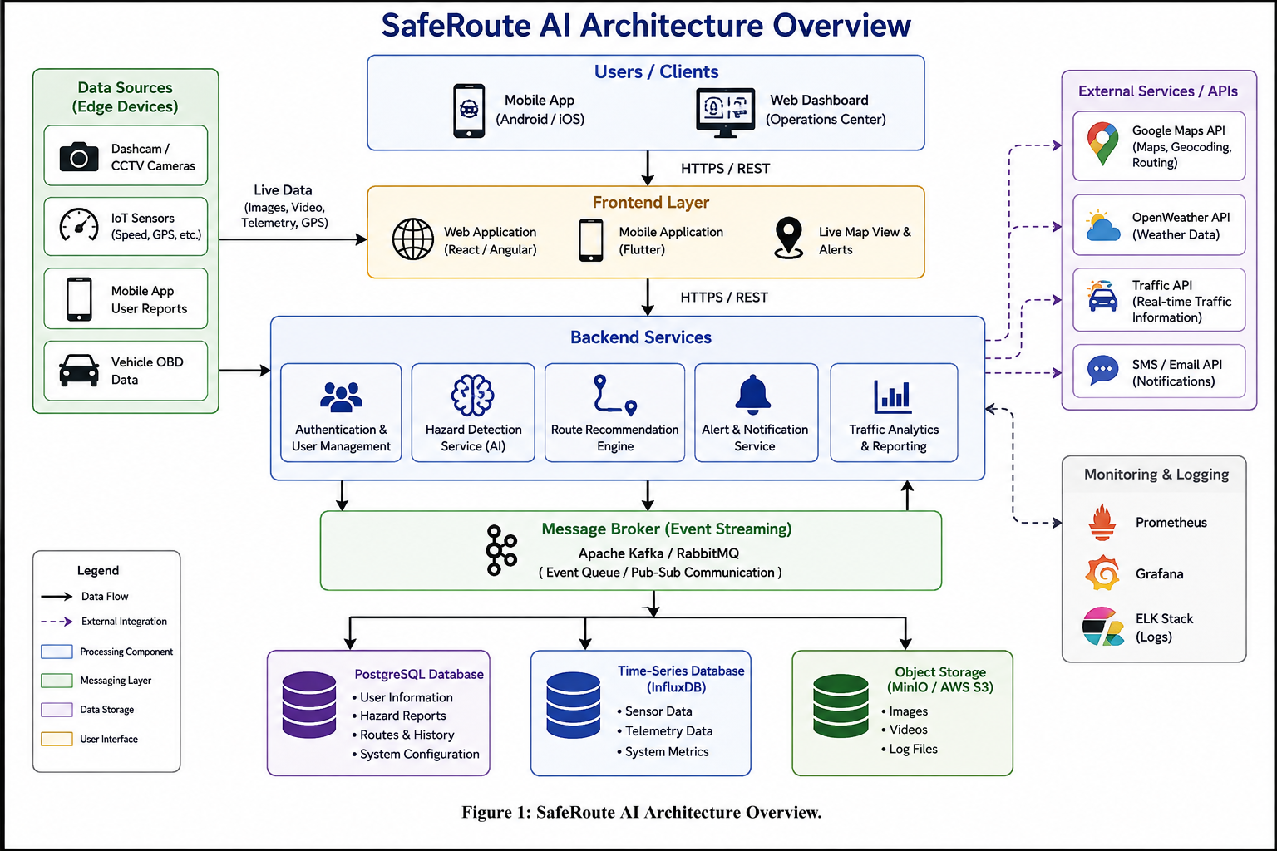

8.Justification of Architectural Decisions
8.1 Overview
This section explains the rationale behind key architectural choices for SafeRoute AI, discusses trade-offs considered during selection, and demonstrates how the chosen architecture supports future enhancements, system integration, and long-term maintainability.ncaidt.ganitara+2
8.2 Key Architectural Decisions and Rationale
Decision 1: Hybrid Edge + Cloud Architecture
Decision: Deploy AI inference on vehicles (edge) and aggregate/process data in the cloud.
Rationale:
- Low Latency: Edge processing reduces round-trip time from seconds to milliseconds, enabling sub-second hazard detection and alerting.
- Bandwidth Efficiency: Transmitting only metadata (hazard type, GPS, confidence) instead of raw video reduces bandwidth costs by 90%+.
- Connectivity Tolerance: Edge buffering ensures no data loss during intermittent connectivity (common in rural/highway areas).
- Scalability: Cloud services handle aggregation, analytics, and alerting at scale without being bottlenecked by raw video ingestion.ncaidt.ganitara+1
Alternatives Considered:
- Pure Cloud Processing: Simpler to manage but fails latency and bandwidth requirements.
- Pure Edge Processing: Impossible for analytics, dashboards, and multi-vehicle correlation.

Decision 2: Microservices over Monolith
Decision: Decompose the system into independent microservices (Ingestion, Hazard Management, Alert & Routing, Analytics, Dashboard).ncaidt.ganitara+1
Rationale:
- Independent Scaling: Ingestion and alerting can scale independently based on traffic patterns (e.g., peak hours vs. off-peak).ncaidt.ganitara
- Fault Isolation: Failure in one service (e.g., Analytics) does not cascade to critical services (e.g., Alerting).ncaidt.ganitara
- Team Autonomy: Different teams can develop, test, and deploy services independently, accelerating delivery.ncaidt.ganitara+1
- Technology Flexibility: Each service can use the best-fit technology (e.g., Python for AI, Go for high-throughput ingestion).ncaidt.ganitara
Alternatives Considered:
- Layered Monolith: Simpler initially but becomes unmaintainable as the system grows; single point of failure.ncaidt.ganitara
- SOA (Service-Oriented Architecture): Heavier governance overhead; slower deployment cycles compared to microservices.ncaidt.ganitara

Decision 3: Event-Driven Messaging
Decision: Use a pub/sub message broker (e.g., Kafka, AWS SNS+SQS) for inter-service communication.ncaidt.ganitara
Rationale:
- Decoupling: Producers (Ingestion) and consumers (Hazard Management, Analytics) are loosely coupled; services can evolve independently.ncaidt.ganitara
- Back-Pressure Handling: Broker buffers events during spikes, preventing service overload.ncaidt.ganitara
- Asynchronous Processing: Non-critical workflows (analytics, reporting) do not block critical paths (alerting).
- Replayability: Events can be reprocessed for debugging, model retraining, or recovery.ncaidt.ganitara
Alternatives Considered:
- Synchronous REST/RPC: Simpler but creates tight coupling and cascading failures during outages.
- Shared Database: Anti-pattern; creates hidden dependencies and schema coupling.ncaidt.ganitara

Decision 4: Database per Service
Decision: Each microservice owns its database schema (e.g., Hazard Service → PostGIS, Analytics → Data Lake).ncaidt.ganitara
Rationale:
- Loose Coupling: Services can evolve schemas independently without breaking others.ncaidt.ganitara
- Technology Fit: Use specialized databases (PostGIS for geospatial, Redis for cache, S3 for media).ncaidt.ganitara
- Scalability: Databases can be scaled independently based on workload (e.g., PostGIS for hazards vs. Analytics DB for trends).
Alternatives Considered:
- Shared Database: Simpler queries but creates tight coupling and migration nightmares.ncaidt.ganitara
- Event Sourcing Only: Powerful but adds complexity; hybrid approach (events + state) is more pragmatic.ncaidt.ganitara

Decision 5: API Gateway Pattern
Decision: Use a centralized API Gateway for authentication, rate limiting, and request routing.ncaidt.ganitara
Rationale:
- Security: Centralized authentication (mutual TLS, JWT) and authorization (RBAC).ncaidt.ganitara
- Rate Limiting: Protect backend services from overload or DDoS attacks.ncaidt.ganitara
- Simplified Client Contracts: Single entry point for all clients (vehicles, dashboards, third-party integrations).
- Observability: Centralized logging, metrics, and tracing for all inbound requests.ncaidt.ganitara
Alternatives Considered:
- Direct Service Access: Simpler but exposes services directly; harder to enforce security and rate limits.

Decision 6: Geospatial Database (PostGIS)
Decision: Use PostgreSQL + PostGIS for storing and querying hazard locations.
Rationale:
- Native Geospatial Queries: Efficient proximity searches, hotspot detection, and route overlap calculations.
- Maturity: PostGIS is production-proven, open-source, and integrates well with analytics tools.
- ACID Compliance: Ensures data integrity for critical hazard records.
Alternatives Considered:
- NoSQL (e.g., MongoDB): Easier schema evolution but weaker geospatial query performance.
- Specialized GIS (e.g., ESRI): Expensive licensing; PostGIS offers similar capabilities at lower cost.

Smart City Integration
- Integration Path: Expose hazard data via APIs to city traffic management systems, emergency responders, and autonomous vehicle fleets.
- Architecture Fit: API Gateway already supports third-party integrations with authentication and rate limiting.
- Summary
- The chosen hybrid edge-cloud microservices architecture with event-driven messaging is justified by its ability to meet SafeRoute AI's core requirements: low-latency detection, scalable processing, resilient communication, and tolerance to connectivity gaps. Trade-offs were carefully considered to balance performance, security, complexity, and cost. The architecture is designed to support future enhancements (V2X, federated learning, smart city integrations) and ensures long-term maintainability through modularity, automation, and observability

